Lab-9 Report
4 bit universal shift register

MIRIYALA PRANAY KAMAL
200030033
Aim of the experiment:
Design a circuit for 4 bit universal shift register controlled by a 2 bit control input and performs the following required operation.

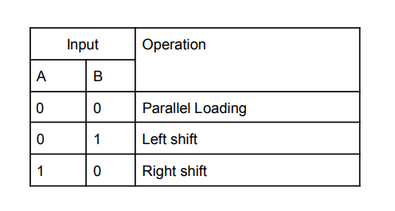

Components used:
- IC-7474 - Dual Positive-Edge-Triggered D-Type Flip-Flops
- IC-74153 - 4-Line to 1-Line Multiplexer [4:1 MUX]
- Power supply
- Breadboard
- 1k resistor arrays (X2)
- LED display
- DIP switches

Design Procedure & Circuit diagram:

Universal Shift register allows both bidirectional and parallel loading of bits. S0 and S1 are selectors, they are also used to select the mode of the register, namely left shifting, right shifting or parallel loading.

S₀ | S₁ | OUTPUT
0 | 0 | Parallel loading
0 | 1 | Left shift
1 | 0 | Right shift
1 | 1 | No change

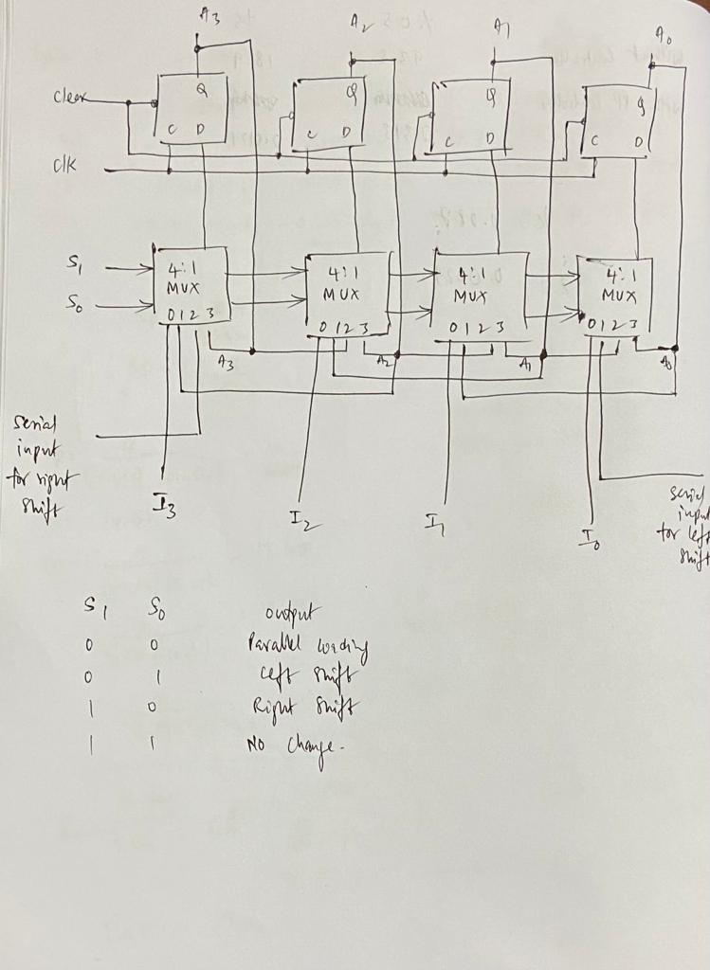

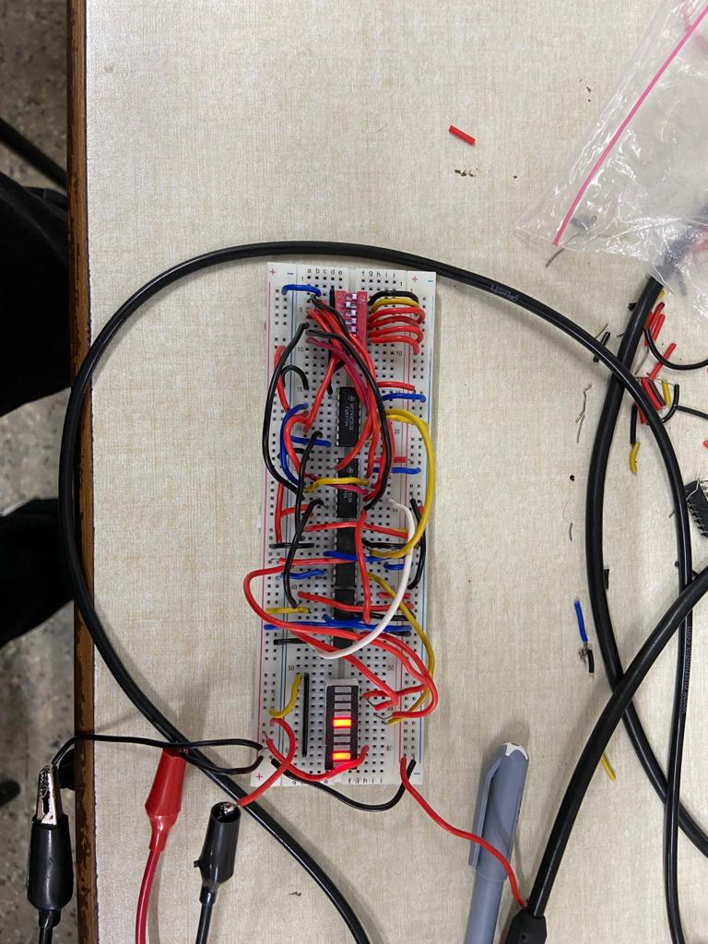
Circuit Snapshots:
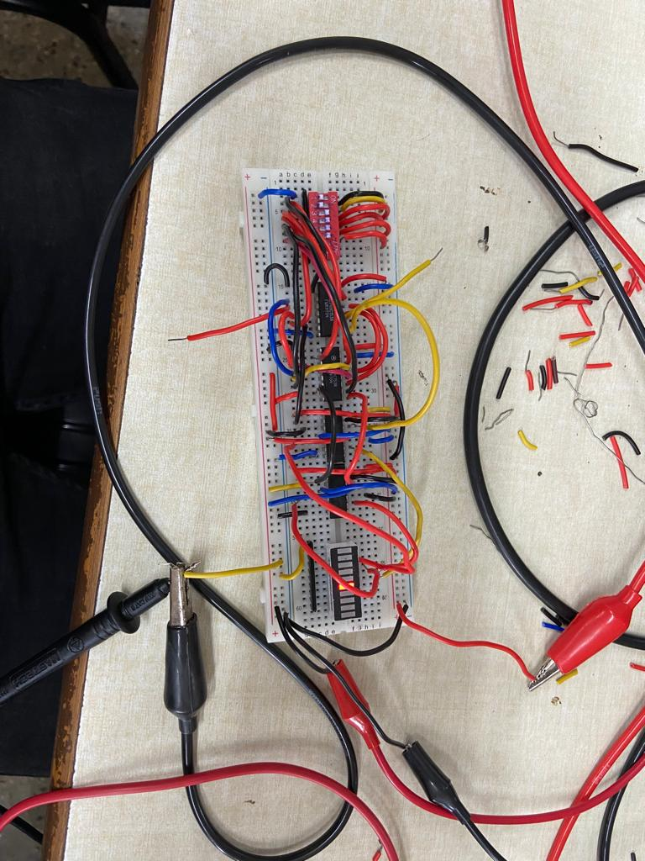

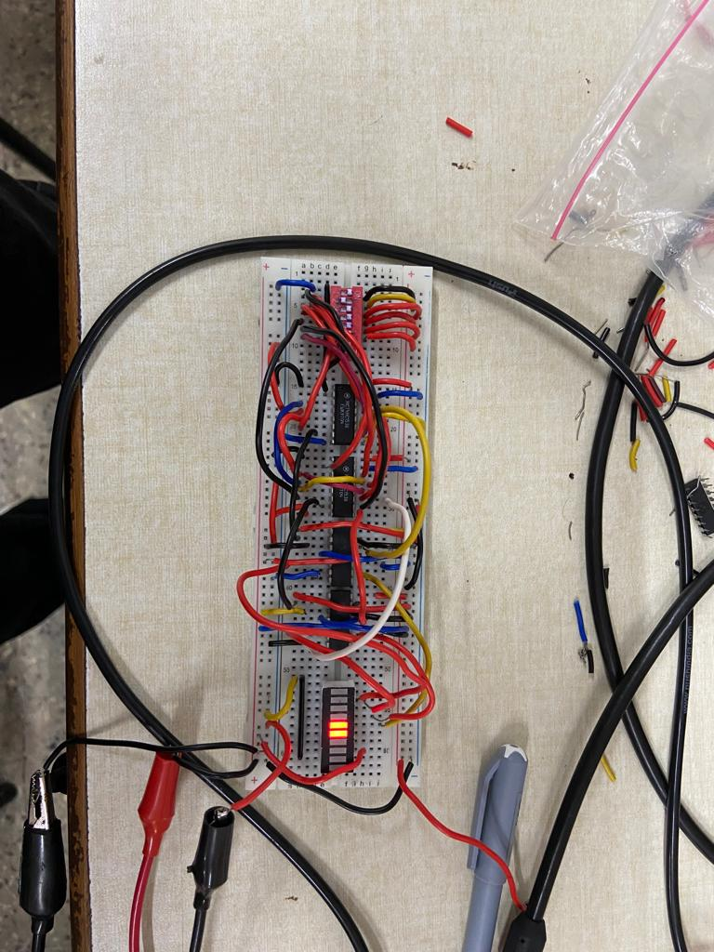
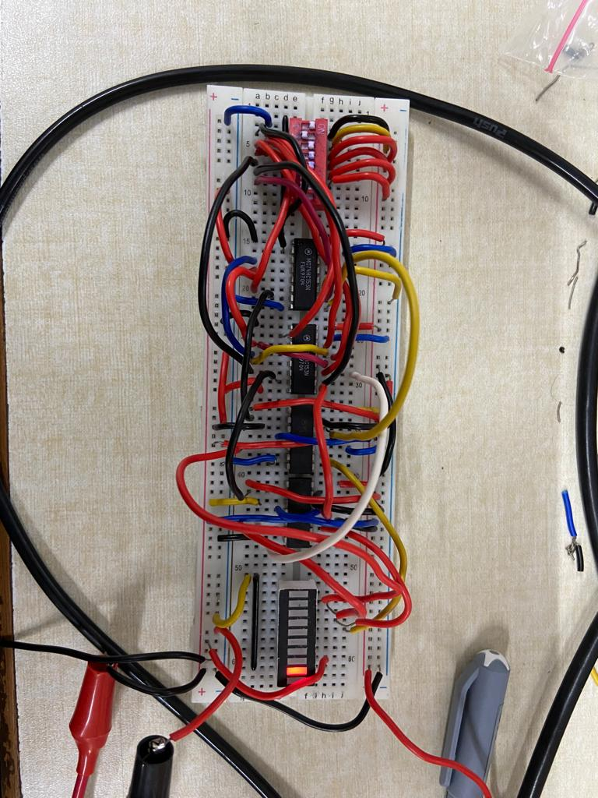

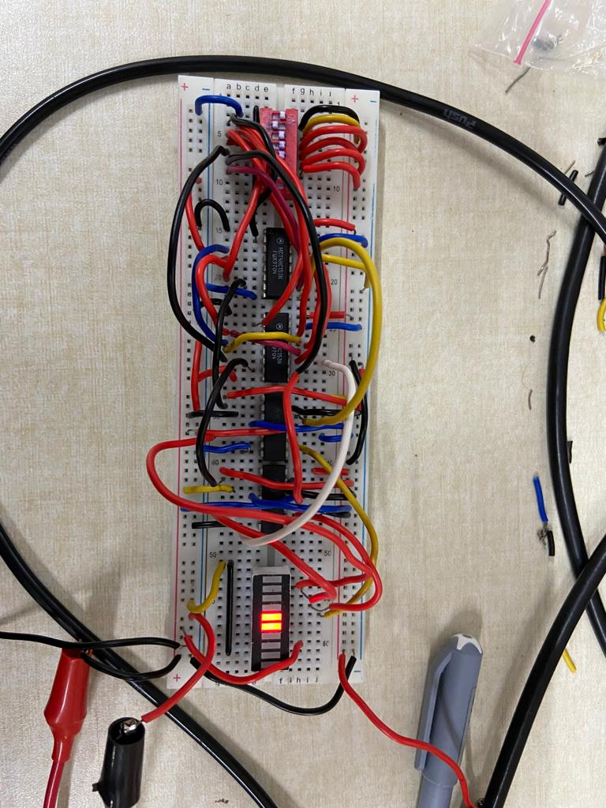

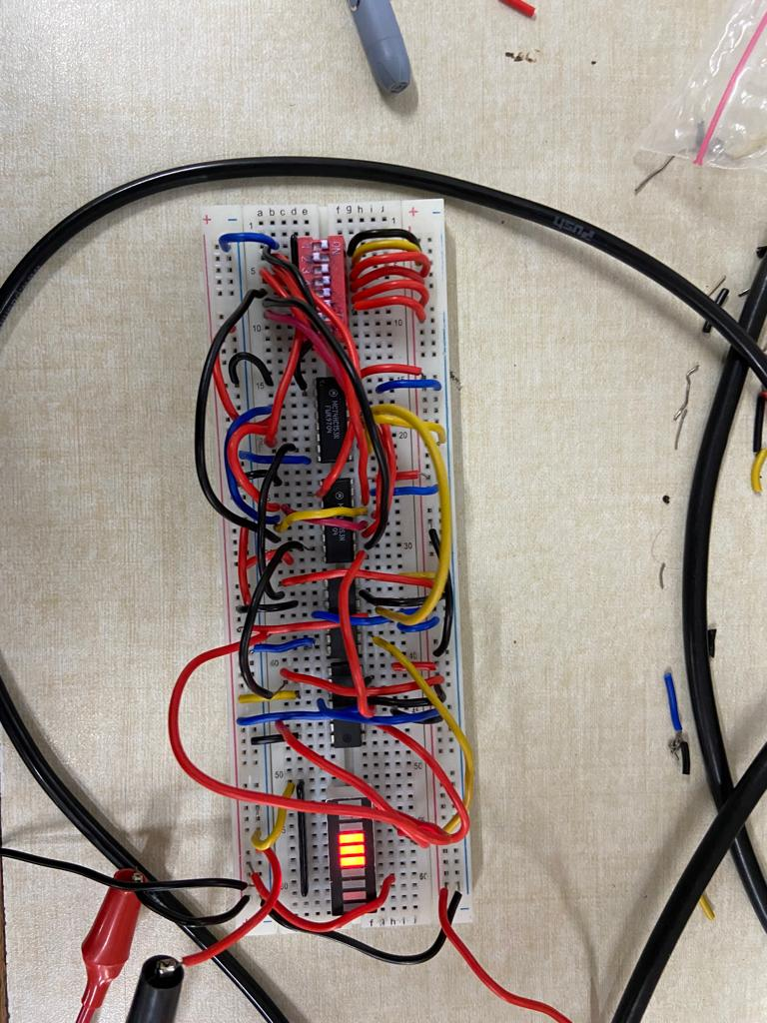
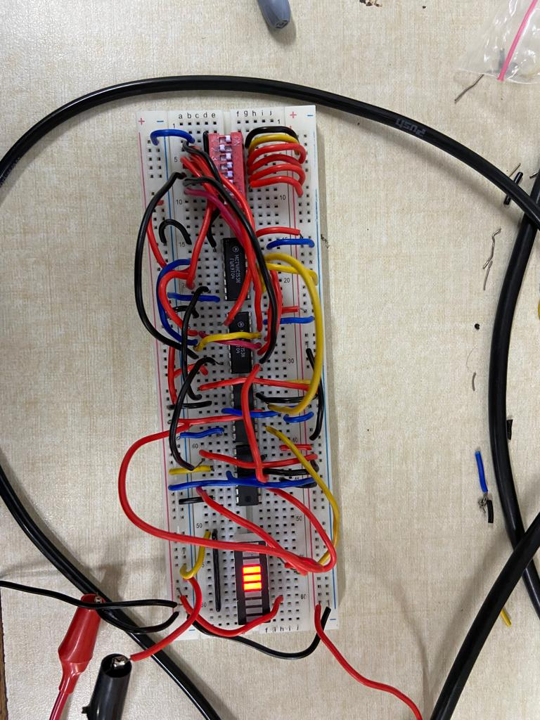

Results and Discussion:

In this experiment, we explored the design procedures of Universal shift registers for the given specifications and implemented the same on the breadboard using Digital D Flip-flop IC’S. We observed the outputs via LEDs and the states of LEDs (on/off) change every 1 second as the clock frequency is 1 Hz, while we have left and right shifting of the bits into the register.

